**4Sight**

**April 2013 v1**

LEGAL NOTICE

*ASU30*

*ASU30 and ATUU30 are acronyms for Adult Smoker Under 30 and Adult Tobacco User Under 30. The term ‘adult’ is defined by local law, but shall in no circumstance refer to any person under the age of 18. Likewise, consistent with BAT’s International Marketing Standards, terms such as ‘consumer’, ‘target consumer’, ‘smoker’, or ‘target audience’ refer only to smokers whom are adults.*

LOCAL LEGISLATION / REGULATIONS

*The material contained in this document may present executions and themes that are not legally permissible or acceptable in some markets. Likewise, because tobacco regulation and the company’s own views on socially responsible marketing change over time, previously approved activities may no longer be permissible. Therefore, you must obtain local legal and CORA approval before proceeding with any activity in your market.*

*COPYRIGHT AND CONFIDENTIALITY*

*© British-American Tobacco (Holdings) Limited 2013. All rights reserved. No part of this document may be reproduced in any form or any means without the prior written consent of British-American Tobacco (Holdings) Limited (˝BAT˝).*

*This document is proprietary to BAT and is provided to employees of the BAT Group and certain trusted contractors working for a member of the BAT Group. It is disclosed solely for use by employees in the course of their employment or by contractors for the purpose of facilitating the provision of services by that contractor to the employing BAT company and for no other purposes. Unauthorised possession or use of this material or disclosure of the proprietary information without the prior written consent of BAT may result in legal action.*

*THIRD PARTY TRADEMARKS*

*“Trademarks, logo designs and/or brand names featured in this material and not owned by British American Tobacco PLC (or one of its group companies) are owned by the relevant proprietor of the particular trademark and/or brand name in question, and are referred to in this document for informational and/or illustrative purposes only.”*

Contents

1. Overview – 4Sight Study: 3

2. How to set up a 4Sight study? 5

2.1 Sample Size and type: 5

2.2 Stimulus materials and requirements: 7

2.3 Interview location and requirements: 10

3. Interview and Questionnaire 11

3.1 Interview Flow: 11

3.2 Questionnaire flow and information areas: 12

4. Key Metrics and Analytics 15

4.1 Action Standard Setting: 15

4.2 Key Deliverables: 15

4.2.1 Is this concept a good idea? 15

4.2.2 Does the product deliver to promise? 16

4.2.3 What is the influence of pricing? 17

4.2.4 How is the concept evaluated overall? 18

5. Research Agency for 4Sight 22

# Overview – 4Sight Study:

4Sight is part of the new BAT 4Suite Innovation Toolkit. The methodology has been designed to test early stage innovative concepts and to provide a volumetric forecast to support the decision to invest to further development and move to the commercial stage, including machinery Capex and any significant use of resources.

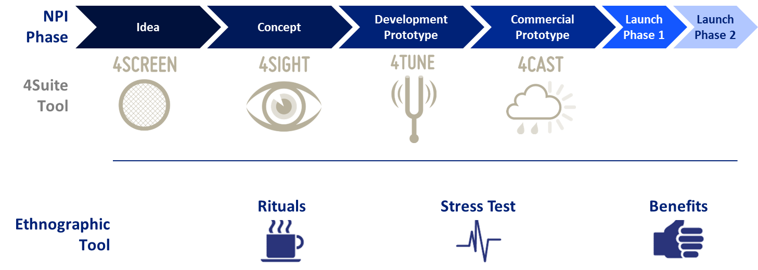

4Suite is a quantitative toolkit and it is coupled with a qualitative Ethnography toolkit “4Real” and its 3 methodologies. 4Sight tool is often accompanied by the 4Real Rituals tool to enrich the understanding on how the concept performs in real life use. Please refer to the 4Real manual for more information.

The key business question that 4Sight helps to answer:

* ***Is the potential size of this innovation large enough to justify the Capex investment?***

4Sight will provide as an outcome an indicative Share Range that can be used as an input for the financial business case.

The tool includes also a number of indicators that will help us to understand the appeal and any potential issues with the concept.

When testing new innovative offers it is very important to understand how they perform compared to other innovations we have tested and compared to other products consumers are interested in. 4Sight provides a benchmarking to the BAT tobacco innovations database as well as the Kantar TNS ex-category innovations database. These benchmarks will help us to understand how the tested innovation performs on the main indicators against other tobacco category and ex-category innovations.

The concept evaluation in 4Sight is based on a branded concept with a preliminary mix – including a one stick smoking experience – to give the respondent a good overall feel and understanding of the offered concept.

4Sight study takes typically about 10 weeks from the moment we have the stimulus materials ready. Additional time needs to be reserved for the planning of the study and development of the stimulus materials.

4Sight is mandatory for Cap3 innovations and optional for Cap2 innovations. 4Sight should not be used for the Cap1 roll-out launches or testing potential for existing products. The main focus of the methodology is in providing early stage potential indicators.

Lead markets for the Cap3 and potential Cap2 innovations are decided and governed by the IPSG and Brand SGM’s. Typically 3-4 lead markets are chosen to measure the global potential of a Cap3 innovation.

Any 4Sight study always requires the sign off from Global Oracle Manager.

# How to set up a 4Sight study?

4Sight is a quantitative test that is done with a *monadic* panel setup where each respondent will test one concept. Due to logistical and confidentiality issues the preferred setup is a central location test where we have full control of the materials shown to the respondents.

## Sample Size and type:

The main objective of a 4Sight study is to calculate the *full potential* of the concept within a market – the minimum sample size for this is 300 smokers. Markets with high category diversity and regional differences would require an even higher absolute sample size. In order to calculate a *total market share projection* the sample needs to cover minimum 80% of the market.

Typically an *all market target group* would include representative parameters like:

* *Demographics* such as *Age* (adult smokers up to 64 years), *Gender* or any other market relevant parameter such as *Ethnicity*.
* *Tobacco Segments* such as: *Price Segments, Flavour, Format* and any other market relevant parameters.
* It is not required to do a geographically nationally representative sample (such as in a GCS or segmentation) however a *good geographical spread and regional representation* should be guaranteed. Especially if there are significant regional skews in terms of brand usage all such regions must be represented in proportion to their contribution to overall market volumes.
* Any *geographical centre* where fieldwork is done must yield at minimum 30 interviews.
* Any *key tobacco segment* needs to have at least 25 interviews as minimum within the sample.
* Due to the minimum sample requirement of 30 and 25 respectively some small regions or segments may need to have a higher than fair sample size and this in turn will drive the overall sample size up. Whilst we can over and under represent segments and brands in the sample to some degree we need to ensure that *the ratio between proportion in market and proportion in sample* does not exceed 1.3.
* Whilst the starting point for the 4Sight is always to include the entire market – we have to consider *legal limitations* that we have on testing tobacco products. *The BAT Group policy is not to ask consumers to test products from a higher Tar category than what they are currently smoking as their Regular or Occasional brand.* For example if the new concept that we are testing is a FF product – it is only possible for us to do the testing among FF smokers. This means that we will have to exclude the lower Tar smokers from the test and assume that their yield to the volume share potential is zero. The research proposal has to clarify any groups that are excluded for legal reasons – their size and the assumed yield. Total market projection will take these consumers into consideration with a zero yield. Please note that to ensure proper quality of the share projection we can only leave out groups that are not allowed from an ethical or legal point of view.

There may be some special cases where on purpose the testing is done only amongst a certain limited target group – rather than testing for the all market potential. For instance we might want to test only amongst Female or only amongst ASU30.

In such case the first thing to do is to align all the BAT stakeholders to be sure that there is clear consensus on the objective. Doing a limited target group study has some negatives that need to be taken into consideration:

* With a limited target group study we will *not be able to use properly the innovation norms or the ex-category norms.* The norms that we have assume an all market setup.
* We will not be able to include limited target group studies into the normative database so they do not generate norms for other studies
* There may well be surprising potential for the offer outside of the target group which the study will now not count in and the potential seems smaller than it would have been in reality.

The standard 4Sight design is always based on a total market projection in order to provide a good input to the Capex decision making. *Therefore any limited target group 4Sight requires the sign off from Global Oracle Manager and from the IPSG.*

In case we are conducting a limited target group 4Sight – the coverage must be at least 80% of the specified target group to qualify for share projection within the target group.

In any limited target group study the *share projection will be strictly limited to the same target group.* Action standards need to be aligned to the study design and built for the same target group.

For both all market and limited target group 4Sight it is also possible to add boosters to cover specific segments or brands. The basic rule of covering 80% of the intended target group applies also within the booster. The minimum sample size for any sub-group / booster share projection is 150.

When testing innovative offers that are going to be priced at a certain price point for example Super Premium price it may be relevant to add a booster that ensures 150 smokers from that price segment to be able to see the potential within the price segment in addition to the total market potential.

As *boosters considerably increase the cost and timeframe of the study* the necessity of them should be discussed with key stakeholders in advance and their role in the decision making clarified. Boosters should only be included if there is a clear business reason to do it.

## Stimulus materials and requirements:

4Sight study requires a comprehensive total concept exposure to ensure that the respondent is able to form a good understanding on *what the concept is, what the benefits are and how the product works*. Even though we are working with early stage prototypes it is very important to put special emphasis in developing good stimulus materials for the test.

It is also important to note that 4Sight is done branded. All the norms that the test compares to are branded norms. *If there is a need to do quantitative non-branded concept testing – please contact Global SP&I team to discuss options.*

The following stimulus materials are needed for 4Sight:

* **Concept board** – either printed or electronic – which explains:
  + *The brand name*
  + *Price*
  + *the concept benefit*
* **Packaging mock-up** for the “touch and feel” so the consumer can get a good understanding on the size and feel. If the concept includes any special packaging features / opening mechanism etc. there should be a working prototype that they can test.
* **Actual product for 1 stick test** – ideally branded sticks if possible - these can be hand-made prototypes however the smoking quality has to be good and the products pre-tested and approved by the product champions.
* **Optional – a video** can be used to further explain or demonstrate the concept and how it works to the respondent if needed.

*All stimulus materials must always comply with the local legislation and must be approved by the local Cora/Legal before starting the research.*

Please note that a proper 1 stick test is required within 4Sight in order for us to calculate a share projection.

Stimulus material amounts need to be discussed with the research agency. Often at this early stage of development it is not possible to have a large amount of stimulus available. Therefore it is very important to review the feasibility and the availability of the stimulus before starting to plan for the test and to discuss any stimulus material limitations with the research agency as early as possible.

Other requirements from BAT:

In addition to the stimulus materials there are some additional things that BAT will need to deliver to the agency for a 4Cast study:

* **Distribution plan / scenarios:** Monthly plan for national Weighted Distribution (especial focus on 1st, 6th, 13th period). The recommendation is to always give 3 scenarios: *Optimistic/Stretch, Realistic, and Pessimistic.* The Distribution plan / scenarios have to be agreed and signed off by the local head of Trade / Marketing Director.
* **Awareness building plan / scenarios:** Monthly plan for national Aided Awareness (especial focus on 1st, 6th, 13th period). The recommendation is to always give 3 scenarios: *Optimistic/Stretch, Realistic, and Pessimistic.* The awareness plan should take into account the planned investment into communication and always be sense-checked against another source such as GCS or KLT and signed off by the local Marketing Director.
* **Adult Smoker population size:** The base source for the population size should be the same as used for the GCS projection. The smoker incidence should be taken from GCS for Regular and Occasional smokers. It is important that we use official sources and that you agree clearly with the agency which numbers will be used and the source. Consistency across studies is also very important.
* **Retail Audit (or in-market sales data if no RA available) data** for the past 3 years. Monthly data on SKU level for all brands in the market: Volume Share and Volume.

## Interview location and requirements:

The recommendation for 4Sight is to do the interviews at central locations due to logistical and confidentiality reasons. The amount of locations depends on the market. Especially when doing an all market projection a good geographical spread and representation of the key regions needs to be guaranteed.

For the data collection method - CAPI is recommended and mandatory in case the design includes the *Price Elasticity* module that is conducted as a choice task. For a simple design that excludes the Price Elasticity Module PAPI is also possible.

The other aspect to consider is confidentiality and how that impacts the stimulus materials. 4Sight is designed to test early stage concepts that the company is likely to invest large sums of money into. At this stage ensuring that the respondents do not take any stimulus materials home or /and that only the recruited respondents see the materials – is essential.

If electronic stimulus is used it is very important that the coordinating agency reviews at an early stage what sort of computers the fieldwork agency has in use. If there is any risk of bad quality computer screens that may devaluate the quality of the electronic stimuli we need to either revert to printed materials or alternatively discuss with the coordinating agency on the feasibility of arranging computers for the fieldwork agency to use.

# Interview and Questionnaire

4Sight is a one visit test with pre-recruited consumers. Typically the consumers are first recruited by using various methods and quota sampling – after which the suitable consumers are invited to the central location interview. The 4Sight interview takes about 1 hour. The exact length depends on the amount of modules included and the type of stimulus materials used.

## Interview Flow:

Brand Awareness, Usage & Disposition

* + The respondent will be asked a few questions regarding current brands in the market. The purpose is to find out if the respondent has any specific attitude towards the test brand house

Concept Exposure

* + The branded concept board will be shown to the consumer
  + The price should be clearly mentioned in the concept board
  + The pack mock-up will be shown to the respondent at the concept exposure stage

Concept Evaluation (Pre Trial)

* + The respondent will answer a set of questions related to the concept (detailed below in the questionnaire flow)

1-Stick Smoking Experience

* + The stick should be branded and close to a final offer
  + The respondent should be given sufficient time to smoke the product and if needed any guidance how to smoke it or how to use the innovative features should be provided in advance. *(Important that these are standard instructions approved by the BAT product champion)*

Offer Evaluation (Post Trial)

* + After the smoking experience the respondent answers again a set of questions related to the concept. The purpose is now to capture if there is any uplift or change in perception after the actual product trial.

Pricing Module (Optional)

* + A truncated *“CBC like” choice task module* will be administered to review the preference of the branded concept/offer at different price points *(price range needs to be specified by BAT)*
  + This module will provide *price elasticity* of the offer. However, please note that volumetric estimation can only be provided for the price option at which the concept was first presented at and not at any other price that was exposed in the choice exercise.

## Questionnaire flow and information areas:

1. **SCREENER**

|  |  |
| --- | --- |
| **Section** | **Question** |
| **SCREENER** | Gender |
| Center |
| Age Screening (Exact Age) |
| Age Screening (2) |
| Trade / profession screening |
| Whether participated in market research |
| Whether participated in tobacco research |
| Smoke cigarettes daily |
| Average daily consumption |
| Regular brand |
| Time with regular brand |
| Demographic questions to be included as per market needs |
| Purchase format – pack or stick |
| Purchase frequency |
| Occasional brands |
| Proportion of Regular and other brands |
| Occasions of smoking |
| Distribution of ADC into occasions |
| Regular brand disposition |

1. **MAIN INTERVIEW**

|  |  |  |
| --- | --- | --- |
| **Section** | **Question** | |
| **BRAND AWARENESS, USAGE & DISPOSITION** | Regular brand reconfirmation | |
| Prompted awareness | |
| Trial in last 3 months | |
| **PRE SMOKE EVALUATION** | Purchase intention | |
| Packs / sticks at trial | |
| Price perception | |
| Overall Liking | |
| Likes of the offer | |
| Dislikes of the offer | |
| Uniqueness | |
| Relevance | |
| Believability | |
| Excitement | |
| Main benefit | |
| Perception grid | |
| Image ratings of the offer | |
| Overall appeal of the offer | |
| **EX-CATEGORY** | Overall Liking 6 point scale for ex-category comparison | |
| **POST SMOKE EVALUATION** | | Repeat Purchase intention |
| Purchase as regular / occasional / rarely |
| Packs / Sticks at repeat |
| Repeat purchase frequency |
| Proportion of Test proposition and other brands |
| Average weekly consumption of Test proposition |
| Price perception |
| Performance versus Expectation |
| Uniqueness |
| Relevance |
| Excitement |
| Image ratings of the offer |
| Overall appeal of the offer |
| Likes of the offer |
| Dislikes of the offer |
| **OCCASIONS** | | Occasions of smoking Test proposition |
| Distribution of weekly consumption into occasions |
| **MOMENTS FRAMEWORK** | | Moments framework |
| **EX-CATEGORY** | | Overall Liking 6 point scale for ex-category comparison |
| **TALK VALUE** | | Sources of information |
| Recommend ability |
| **FUTURE SHAPERS** | | Future shapers questions |

1. **OPTIONAL SECTIONS**

|  |  |
| --- | --- |
| **OPTIONAL SECTION: PRICE ELASTICITY** | |
| **PRICE ELASTICITY** | CBC like price elasticity module |
|  |
|  |
|  |

|  |  |
| --- | --- |
| **OPTIONAL SECTION: SMOKER BEHAVIOUR** | |
| **This section will move up within the questionnaire flow if included** | Previous brand |
| Substitute brand |
| Forming evoke set |
| Pre-Disposition of Test proposition masked by evoke set brands |

# Key Metrics and Analytics

## Action Standard Setting:

4Sight *Action Standard* should be set around the *total market share potential projection*. 4Sight will provide as an outcome a Share Range projection. If the action standard falls within the range, or the range is higher than the set target – the action standard has been met.

## Key Deliverables:

4Sight has a standard output template that will be used in all the studies. Please refer to the example on the PRISM site.

The 4Sight analysis is divided into 4 broad areas:

1. *Is this concept a good idea?*
2. *Does the product deliver to the promise?*
3. *What is the influence of pricing?*
4. *How the concept is evaluated overall?*

### Is this concept a good idea?

In this section the key purpose is to see how the innovation is performing as a concept. Key concept measures such as *Uniqueness, Excitement, Believability, Relevance and Appeal* are evaluated against a normative innovations database and Ex-Category database. *Please note that the availability of norms needs to be checked in advance when planning the study and selecting the markets.* It is important to remember that we do not have norms available for all markets in the early stages. In case that no market specific norms are available the coordinating agency will review the availability of norms from the same Region or globally and propose what can be used.

In addition we will be evaluating how the concept performs on specific imagery parameters that are relevant to the brand offer compared to the respondent’s regular brand. The section includes also open answers on likes and dislikes and to help to generate the overall view whether the concept is a good idea or not.

The following charts illustrate the dashboards that show the absolute ratings and the comparison to the normative database

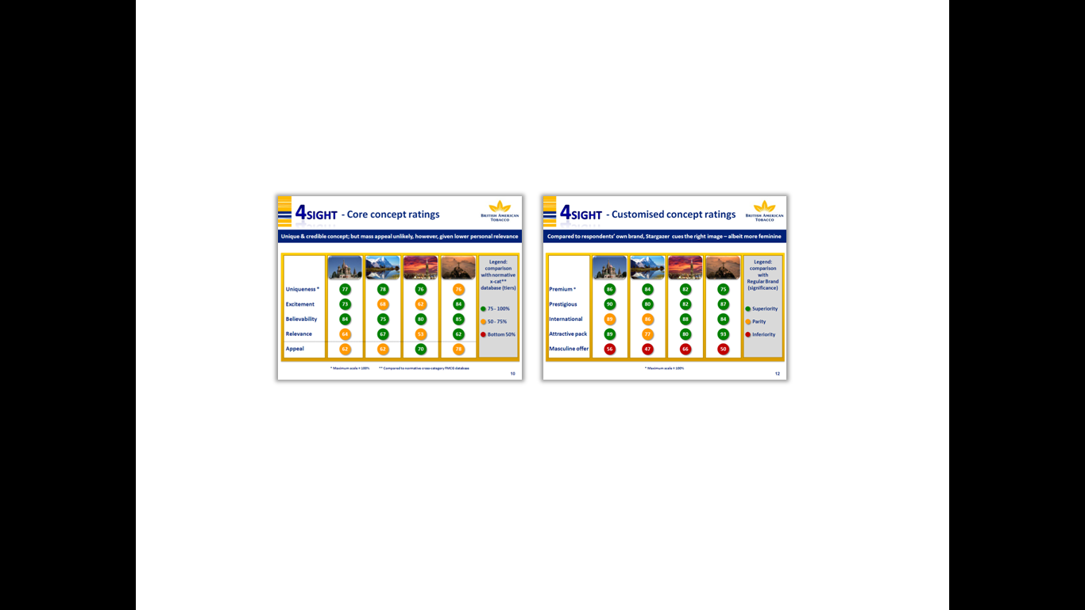

*\* Please note that for purpose or reporting all mean scores will be converted to a 100 point scale. The figures in the slides above are converted ratings.*

### Does the product deliver to promise?

After the concept evaluation the respondents are given one stick to test and smoke the new product. This will help the respondents to get a good understanding on how the entire concept is supposed to work and to get a feel of the product. It is important to note that this is not a proper product test the purpose is to get the immediate reactions and especially to see if the product is living up to the expectations and the promise that the concept was portraying.

After smoking the one stick the respondent evaluates the product on key product imagery and we can see how the product experience impacts the purchase intention. Additionally spontaneous likes and dislikes are recorded and these may help to see if there are other significant issues with the product that need to be taken into consideration.

The product dashboard:

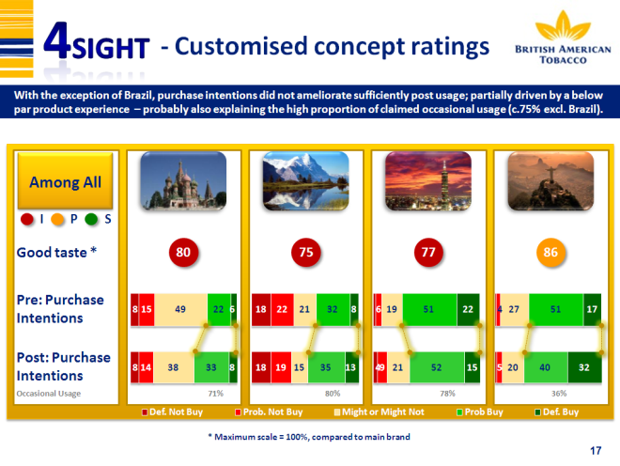

### What is the influence of pricing?

The concept is always displayed with a price point. Price plays an important role in how the consumers perceive the overall offer. After having experienced the product the respondent will form an opinion about the value of the offer – whether they feel that the price is justified or not. This element is captured via the *Value for Money* attribute and also via the overall evaluation of the Price Perception – benchmarked against the appropriate norms. This pricing section is the standard one in all 4Sight studies – not to be mixed up with the optional price elasticity module.

Price Perception dashboard:

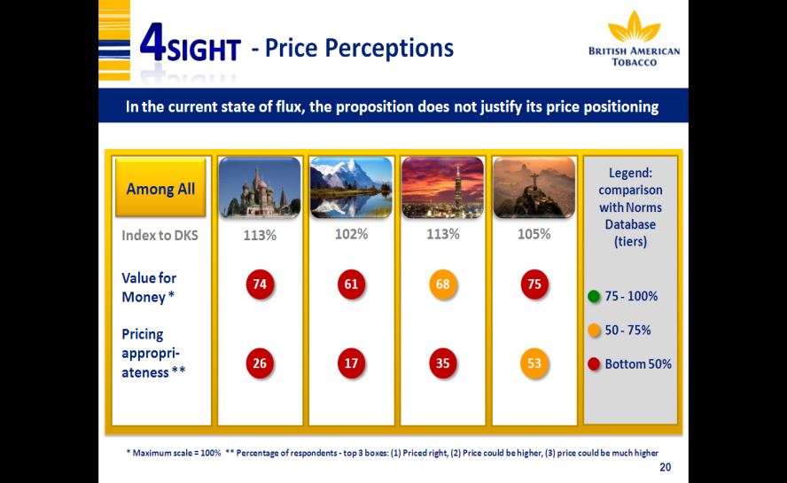

### How is the concept evaluated overall?

The overall evaluation looks at how the consumer evaluates the innovative concept at an overall level considering the entire offer. Also we look at which occasions and moments are most appropriate for the offer, what is driving adoption *(Consumer Adoption Pathway)* and finally what is the overall volume share potential that this innovation can generate.

**Volume share potential:**

* Volume share potential is calculated using a *Trial-Repeat Model*.
* The share is indicated as a range +/- 30%
* In a Trial-Repeat Model, the estimates of trial and repeat purchase probabilities are derived from the purchase intention questions.
* Calibration factors are applied to the data to reduce the element of respondent over-claim for the purchase intention. Calibration is done using variables like *Cultural Coefficient and Imagery parameters.*
* For example the respondent needs to feel that the Packaging is attractive enough to try and likewise that the product tastes good. Without such basic indications of acceptance it is very unlikely that any purchase intention will actually lead to action.

* Also it is important to know whether respondent is willing to adopt this product for Regular or Occasional usage as that will have a direct impact on the overall potential of the offer. It is expected that volume contribution through Regular usage will be significantly higher than that generated by Occasional usage.
* The derived trial probability is then modelled into a cumulative trial volume (including both regular and occasional usage), month by month, based on predicted awareness build and distribution levels.

**Talk Value Adjustment:**

An innovative offer is likely to generate a level of interest and excitement and the consumers may be telling their adult smoker friends and family about the new product. Likewise the consumers may see other smokers using the new product and become aware of it this way.

This factor – *word of mouth and the interest generated when seen* is called *“Talk Value”.* The size and extent of *“Talk Value”* factor varies between different products – some may generate plenty of it and some nearly none.

As the communication and advertising to consumers is increasingly banned across markets “Talk Value” may be a significant driver of awareness in certain markets. The 4Sight questionnaire includes a set of questions that will calculate a *Talk Value Index* for the offer and that index will be used to adjust the final share projection.

**Cannibalisation:**

The 4Sight model can also calculate cannibalisation from the parent brand. If the tested offer is a line extension or a new range for an existing brand in the market we can calculate the level of cannibalisation and the net gain for the parent brand. In order to do this we will need a minimum 150 sample of the brands OWN smokers and a separate share modelling will need to be done among them.

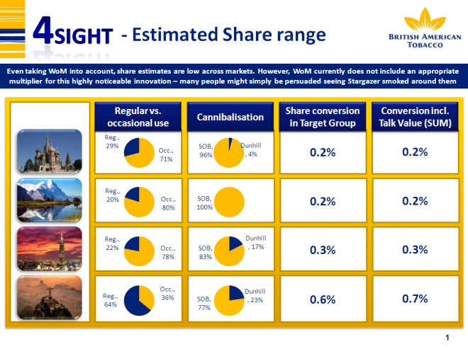

**Occasions and Moments:**

In order to understand better the potential usage and relevance of the innovative offer – the 4Sight study incorporates the Occasions and Moments Framework analysis. The respondent is first asked to rate their regular smoking patterns against the list of Occasions and Moments and later the same is done with the tested offer. In the analysis we can then see in which Occasions and Moments the innovative offer is over or under indexing compared to the respondent’s regular behaviour. Please note that this is an indication of the Occasions and Moments that respondents are associating this new offer rather than measured behaviour.

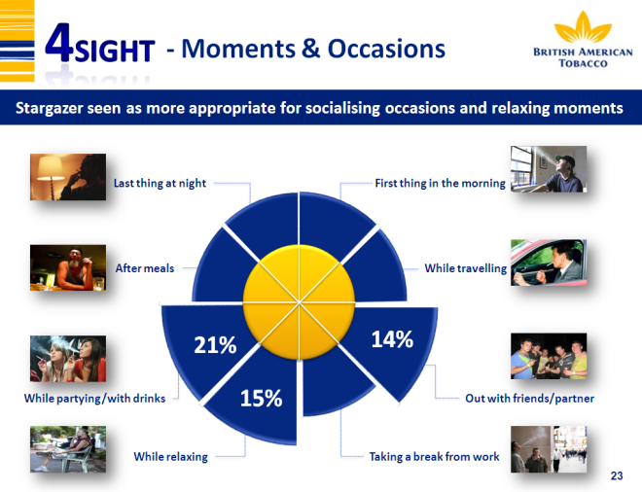

**Price Elasticity Module (OPTIONAL):**

Price Elasticity is measured through a *choice based conjoint exercise* which is done at the end of the interview. Discrete choice tasks are created from the test offer and existing key brands in the market and these are presented to the respondent at different price combinations. Same technique is used here as what we use in the CBC pricing study.

The outcome is the price elasticity of the test offer across the exposed price range.

Please note that this module requires separate programming and analytics therefore it is important that the PIB will already specify that a Price Elasticity Module needs to be added. The price range where elasticity is tested needs to be decided in advance by BAT. If the Price Elasticity Module is added the fieldwork must be conducted using CAPI.

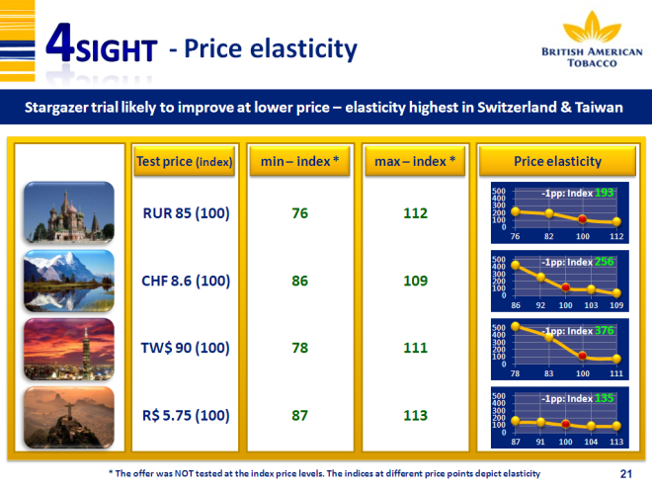

**Normative Databases:**

A BAT proprietary normative innovations tobacco database has been built and is maintained and updated by IMRB International. The base is the vast range of STM studies done in the past and all future 4Sight and 4Cast studies will be part of the database. As this is a new thing for BAT and the amount of suitable benchmarks varies a lot across markets it is very important to discuss the availability of the benchmarks with IMRB International right at the outset of the study.

What is getting benchmarked? *Overall Appeal, Good Taste, Value for Money, Pack Attractiveness and Product Quality* can be benchmarked against the database to see in which quartile the offer is positioned in. This will give a further idea on the future potential compared to other innovations. As with everything in the 4Sight study it is important to remember that we are dealing with early stage testing and making decisions based on indication of potential. This should not be mixed up with a 4Cast study which tests and simulates the launch of a ready mix.

The Ex-Category benchmarking (beyond Tobacco Category) is done by utilizing the TNS normative database. Depending on what type of innovation we are testing the coordinating agency will propose a suitable benchmark from the database. For instance the benchmark can be “durables” or “non-durables” depending on the type of innovation.

Important to note that only key concept measures like *Uniqueness, Excitement, Believability, Relevance and Appeal* can be benchmarked to Ex-Category norms.

# Research Agency for 4Sight

All 4Sight studies are coordinated by IMRB International. Fieldwork agency can be selected as per our normal process.

For the Ex-Category benchmarking, we use the TNS database and this service needs to be purchased from TNS at an additional cost. If Ex-Category benchmarking is needed IMRB will contact TNS to obtain a quote and will handle the interaction with TNS to get the relevant norms.